ANTaR is an independent, not-for-profit and community-based organisation working to promote justice, rights and respect for Australia’s First Peoples. ANTaR listens to and supports the aspirations of First Peoples and works to educate the wider community, shape public opinion, speak up against injustice and influence public policy to advance our vision.
ANTaR ACT
ANTaR is a national organisation with state and territory ANTaR groups. At ANTaR ACT, we work on both national and local issues, helping to support the campaigns of ANTaR national while also focusing on issues specific to the ACT.
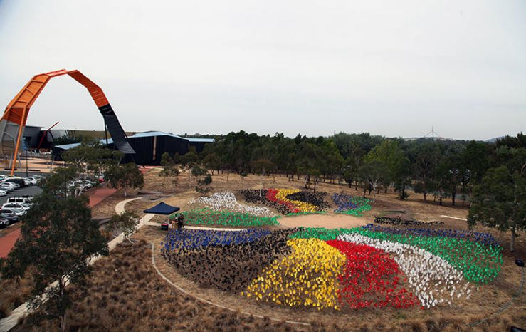
To do this, ANTaR ACT works with local Aboriginal and Torres Strait Islander organisations to understand local issues, support local events and raise concerns. We also work with other community organisations to encourage respect for the rights and cultures of Aboriginal and Torres Strait Islander peoples.
ANTaR ACT participates in shaping and implementing national campaigns, maintaining regular contact with our national office.
We work on a wide range of issues, including youth justice and constitutional recognition.
As well as running campaigns, we have stalls at community events providing information and selling goods produced by Aboriginal communities.
Support ANTaR
February 2014 Sea of Hands, Photo: Paul Herbertson AIATSIS
Become involved: ANTaR ACT is made up of volunteers who meet regularly to discuss upcoming events and campaigns. All are welcome to our meetings and there are many ways to support our work, depending on your skills, interests and available time. If you would like to be involved please contact us via our website or Facebook
Attend events: ANTaR ACT holds several public events throughout the year. We also send out emails on a range of events occurring throughout Canberra to promote reconciliation. You can request to be on our email list at one of our stalls or via our website.
Donate: Donations are always welcome to provide funds to assist Aboriginal and Torres Strait Islander organisations, enable campaigns and coordinate ANTaR at a national level.
Do you have something ANTaR can help with?
Please let us know if you have ideas, events or campaigns you would like ANTaR ACT to support.
Contact Us www.antar.org.au (national website), antaract.wordpress.com (local website), antaract@yahoo.com.au (email) or Facebook (ANTaR ACT).

